**The Untitled Horror Game Experience**

-By Samik Bhatia

**Tools Used-**

1. Unity
2. C#
3. Blender
4. Visual Studio
5. iPhone 14 Plus
6. Chat GPT
7. Various websites for assets, sounds, etc.

**About the Project-**

* A Horror-like experience made in Unity, focuses on providing the player with a basic puzzle to solve in a ruined bathroom, with enhanced graphics and interactions.
* This game has been coded in C#, with 1000+ lines of code
* Uses different free-to-use non-copyrighted sounds, plus some sounds that were recorded by an iPhone 14 Plus device.
* Uses textures that were downloaded from external free texture websites, or captured by an iPhone 14 Plus device.
* Uses Visual Studio to maintain the various scripts separated by the different logics used (Player movement, Light Flickering, etc.) and the backend code of the game.
* Used Chat GPT to guide through the process of making this complex project, and overall enhancing the behaviour of the code and the time-complexity it had.

**Screenshots-**

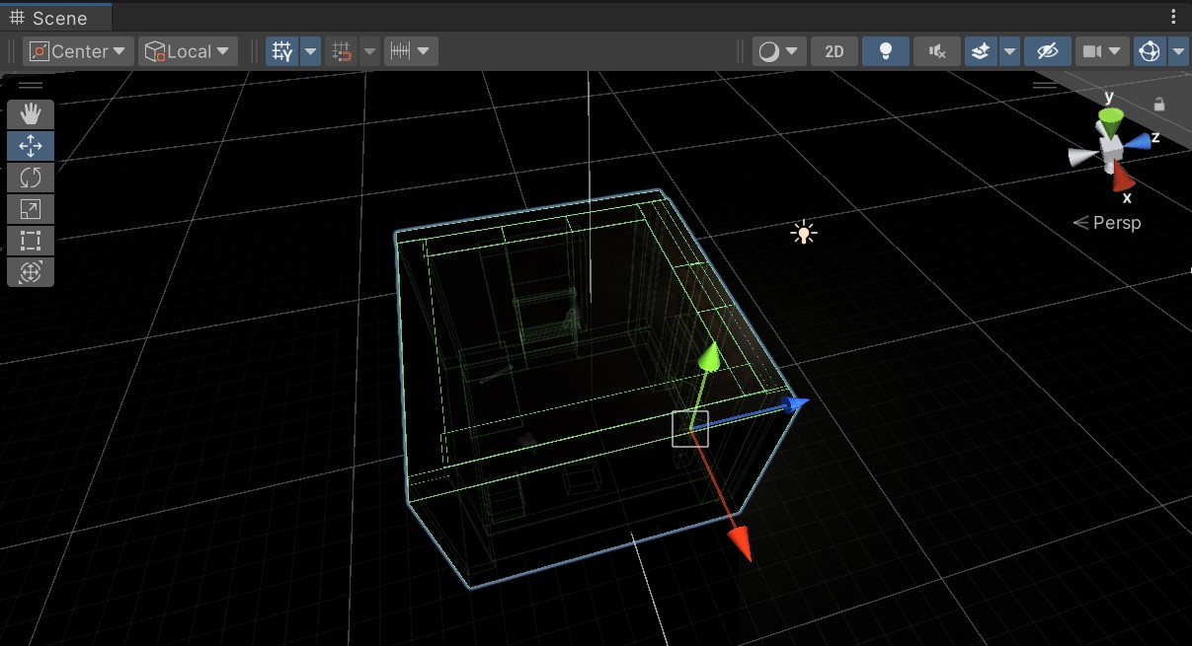

Fig 1- Blueprint of the Structure of Bathroom

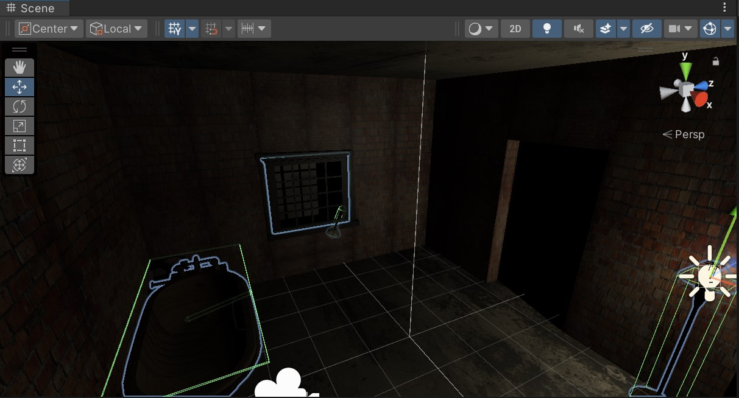

Fig 2- Interior Design of the Bathroom

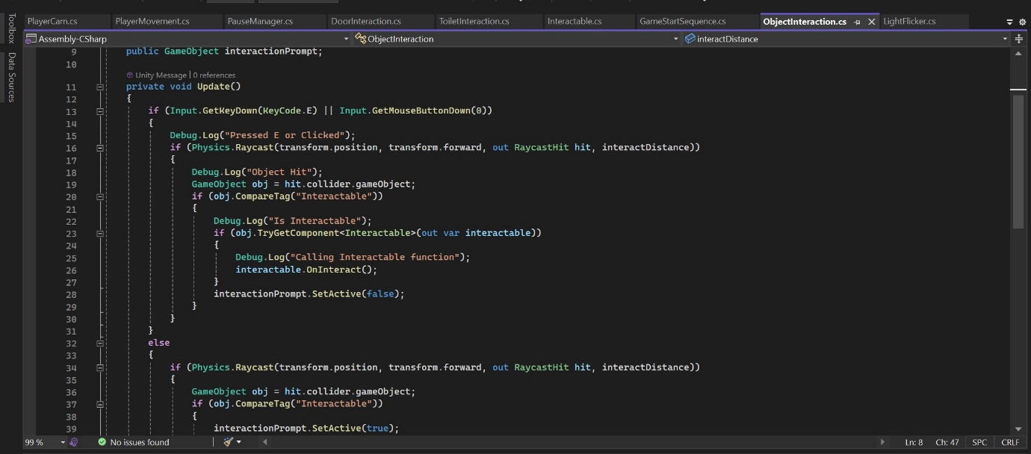

Fig 3- C# Script used for Object Interaction

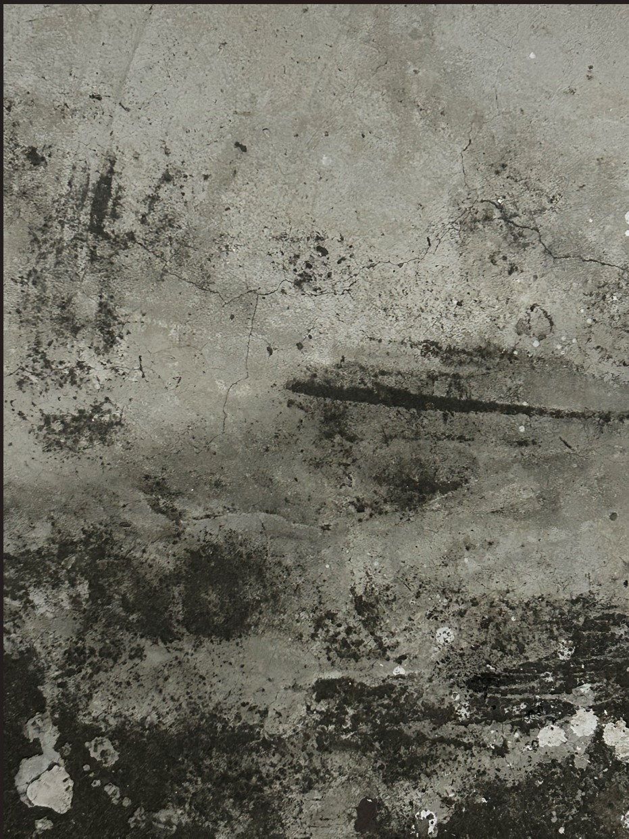

Fig 4- Texture used in the Bathroom (captured by iPhone)

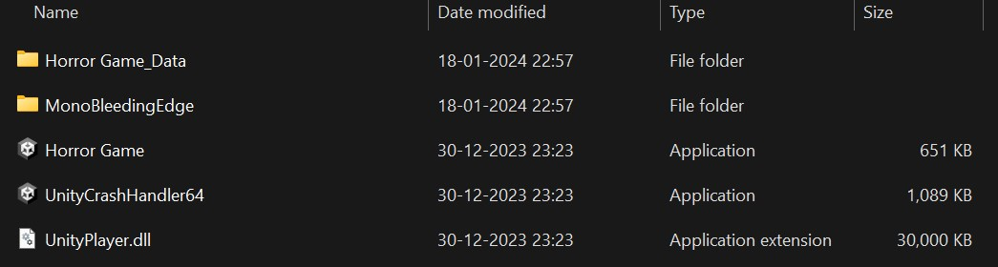

Fig 5- Unity Build of the Project

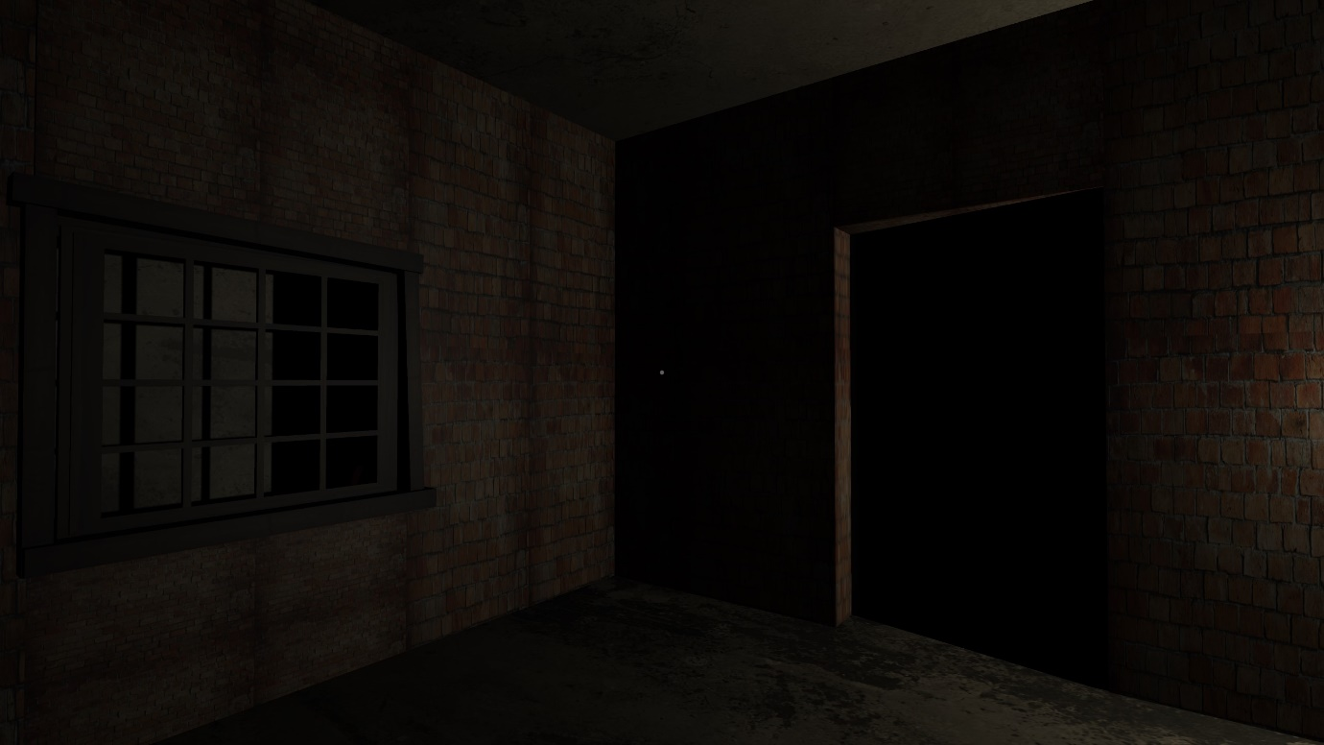

Fig 6- Gameplay Screenshot